National University of Computer and Emerging Sciences


Programming Fundamentals CS118 Laboratory Manual

Course Instructor Mirza Mubasher Baig
Lab Instructor#01 Fraz Yousaf
Lab Instructor#02 Samia Akhter
Semester FALL 2021

FAST School of Computing FAST-NU, Lahore, Pakistan

National University of Computer and Emerging Sciences

 | Lab No 6
 | Course Name | Programming Fundamentals | Course Code | CS188
 | Program | BS(DS) | Semester | Fall 2021
 | Duration | 2.5 hours | Total Points
 | Lab Date | 05-Nov-2021 | Weight | 3%
 | Section | BDS-1A | Page(s) | 9

Topics Covered: Functions
Use Visual Studio Community 2019 or simple IDE available at https://www.onlinegdb.com/ to write the programs

Submission Instructions:

Save all .cpp files according to the following naming convention
{ROLLNO}_{TASKNO}.cpp FOR EXAMPLE. 21L-XXXX _P01.cpp, 21LXXXX_P02.cpp, 21L-
XXXX_P03.cpp

- Now create a new folder according to the following naming convention
{Section}_{ROLLNO}_{LABNO} e.g. C1_21L-XXXX_L06, C2_21L-XXXX_L06

- Move all of your .cpp files to this newly created directory and compress it into a single
.zip file.

- Submit this compressed file on Google Classroom.

Functions in C++

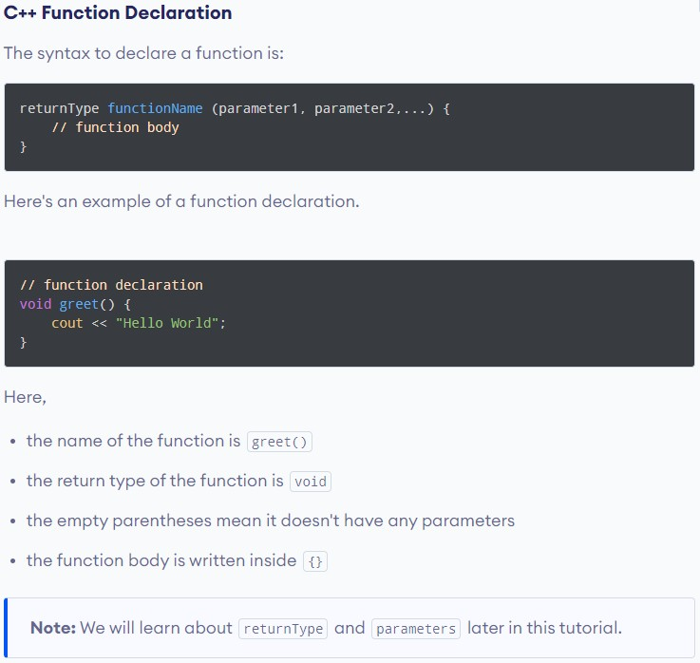

Calling a Function

In the above program, we have declared a function named greet() . To use the greet () function, we need to call it.
Here's how we can call the above greet( ) function.

#1nc I ude<1os t reams
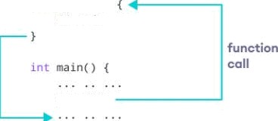
vold greet t )
/ / code

How Function works in C++

(Don’t submit code for this problem)
Practice Problem
Write a function named power that takes two integer parameters a and b. And returns the power as 𝒂^{𝒃}.

Input Format:
- First line contains input a
- Second line contains input b

Note:
- 𝑎^{𝑏} = 1, 𝑖𝑓 𝑏 = 0
Sample Input#1: 12
2

Sample Output#1: 144
Sample Input#2: 3
4

Sample Output#2: 81
Sample Input#3: 15
0

Sample Output#3: 1
Sample Input#4:
-5
3

Sample Output#4:
-125

(Submit codes for questions starting from here)

Problem#01
Write a function named check palindrome that takes an integer parameter number and displays the corresponding output.

Palindrome: A palindrome is a word, number, phrase, or other sequence of characters which reads the same backward as forward, such as madam or racecar or the number 10201
For example:
11211 is palindrome
1222 is not a palindrome.
4444 is a palindrome.

Problem#02
Write a function named rectangle which takes two integers height and width as parameters of the function. That function is responsible to draw the rectangular pattern shown below in the Sample Cases.

Note:
- If user enters a non-positive number, display “Rectangle printing is not possible.”
- Use of Nested Loops is Mandatory

Sample Input#1: 3
4

Sample Output#1: OOOO
OOOO OOOO
Sample Input#2: 9
1

Sample Output#2: O
O O O O O O O O
Sample Input#3:
2
-7

Sample Output#3:
Rectangle printing is not possible.
Sample Input#4:
0
12

Sample Output#4:
Rectangle printing is not possible.

Problem#03

Write a function named displayseries that takes two integer parameter number and rows and then displays the corresponding series pattern.

For user input Starting Number = 5 and Rows = 6,
output should be:
5 * 6 * 7 * 8 * 9 * 0 *
1 * 2 * 3 * 4 * 5 *
6 * 7 * 8 * 9 *
0 * 1 * 2 *
3 * 4 *
5 *
Note: Code should be generic i.e. it should run for any starting number ranging from 0 to 9 and any row number.

Problem#04
Write a program using the C++ programming language to print all the prime numbers between two given numbers by creating a function.

Problem #5

Write a program that inputs a sequence of non-negative numbers terminated by a negative value and show the sum, average, maximum and minimum of the non-negative numbers

Sample Input | Sample Output
10 20 30 40 50 -10 | Sum = 150  Average = 30  Maximum = 50  Minimum = 10
13 2 15 5 30 -10 | Sum = 65  Average = 13  Maximum = 30  Minimum = 2

.

